Version 1.0

Revision History

|  |  |  |  |
| --- | --- | --- | --- |
| **Date** | **Version** | **Description** | **Author** |
| 12/12/2019 | 1.0 | details | Tran Van Dat |
|  |  |  |  |
|  |  |  |  |
|  |  |  |  |

Table of Contents

1. Introduction 2

1.1 Purpose 2

1.2 Scope 2

1.3 Definitions, Acronyms, and Abbreviations 2

1.4 References 2

1.5 Overview 2

2. Flow of Events—Design 2

3. Derived Requirements 2

# Introduction

## Purpose

This document describes how the Log-out Use case is realized within the design model

## Scope

This document applies to the Computer Shop System which will be developed by our group.

## Definitions, Acronyms, and Abbreviations

None

## References

None

## Overview

In the following section, Use-Case Realization Specification of the Log-out Use-Case of the Computer Shop System is provided in detail. This section contains diagrams sequence and class diagrams with relationships that participate in the realization of the use case.

# Flow of Events—Design

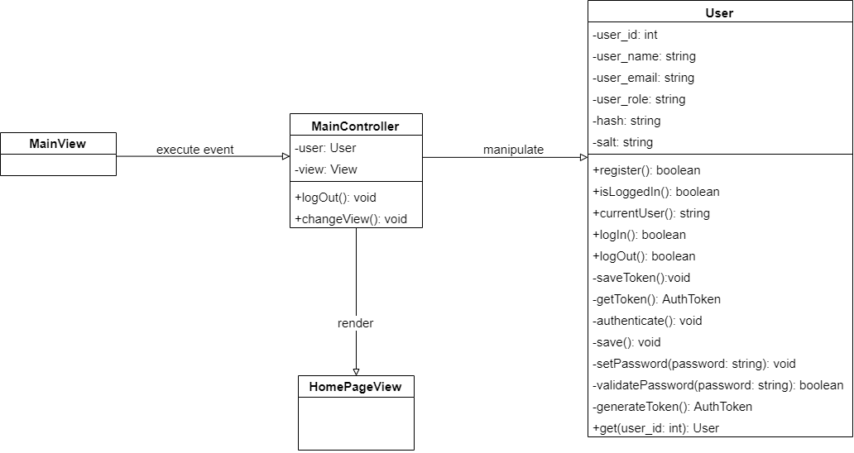

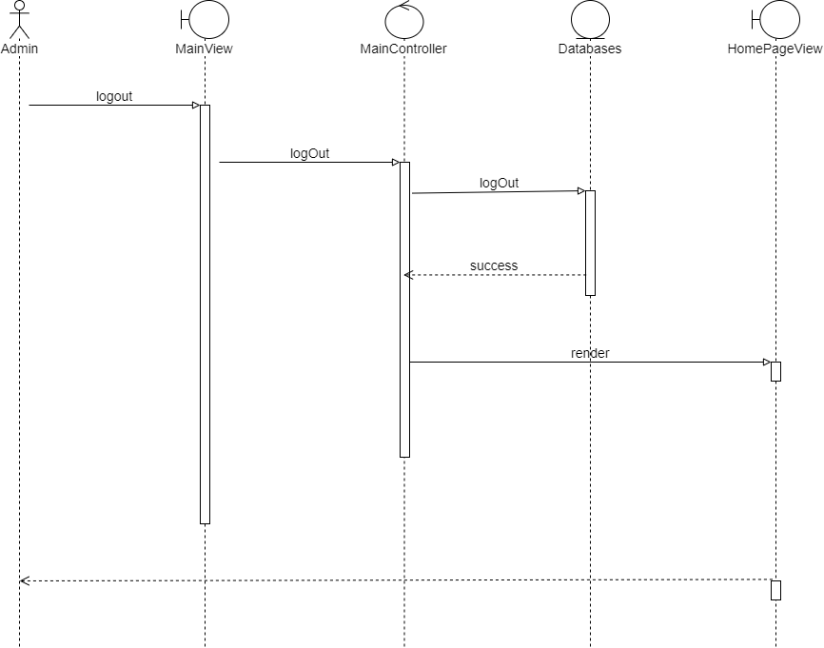

# Derived Requirements

None